
PB-T2/IP-CQP/1221/B 7-APR-2022
PRE-BOARD EXAMINATION 3 – TERM II (2021-22)
Subject: Informatics practices  Grade: XII |  | Max. Marks: 35  Time: 2 Hrs
SECTION A
 | a) Which of the following device send data to every connected node:  (i) Switch (ii) Hub (iii) Router (iv) Gateway |  | 1
 | b) Which out of the following, will you use to have an audio chat with an expert sitting in a far- away place to fix up a technical issue?  - VoIP  - Email  - FTP |  | 1
 | a)What is the significance of cookies stored on a computer? |  | 1
 | b) How is it easier to diagnose fault in Star topology than in Bus topology ? |  | 1
3. | Write the output  i) SELECT POWER(-2,3);  ii) SELECT MOD(10,7);  or  Differentiate between single row functions and multiple row functions with example. |  | 2
6. | Write the sql command to perform the following:  i) Display name of the day and month of your DOB.  ii) Display current date and time. |  | 2
7. | Differentiate between group by and order by clause in sql |  | 2
8. | Explain the purpose of Modem and Gateway |  | 2
9 | Write SQL query to create a table “Book” with the following structure  Table: Registration  Field name Datatype Size Constraint  Book_Id Integer 2 Primary Key  BName Varchar 20 Not Null  Category Varchar 10  Issue_Dt Date |  | 2
6 | Consider the below mentioned table of Electronics,  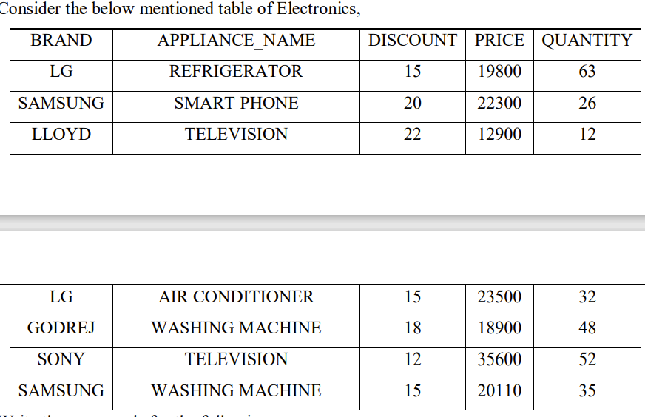  Write the commands for the following:  a. Display the average discount of each brand having quantity more than 50.  b. Count the total number of washing machine available in the table.  c. Display the Brand , Name of Appliance ,price from the table that has the highest price . |  | 3
7 | (a) While creating the table Emp(T-id,Tname,salary,dept) last week, Ms. Sharma forgot to include the column course_attended. Now write a command to insert the course_attended column with VARCHAR data type and 30 size into the Emptable? (1)  (b) Ms Sharma forgot to add a primary key while creating the emp table. Write the query to set T_id as the primary key.(1)  (c) Write the command to increase salary of all teacher by 10%. (1) |  | 3
8 | Consider an EMP table(Empid,Firstname,lastname). Write the query for each of the following.  i. Display LastName and Firstname from emp table who have "in" in the second or third position in their first names  iii. Display the Firstname from emp table that are 5 chars long.  iii. Display the 2 letters of firstname starting from third character. |  | 3
 | Section C
1. | Consider the following table.  Loan_accounts  Write MySQL commands for the following  - Display the IntRate of all the loans started in 2018.  - Display the details of all the loans whose rate of interest is not NULL.  - Display the total loan amount for each loan type.  - Display last two chars of cust_name of female customers. |  | 4
  AcNo | Cust_name | Loanamount | IntRate | StartDate | Type
  1 | Mr.R.K.Gupta | 300000 | 12.00 | 2019-07-19 | HouseLoan
  2 | Mr.S.P.Sharma | 500000 | 10.00 | 2018-03-22 | VehicleLoan
  3 | Ms.K.P.Jain | 300000 | NULL | 2022-03-08 | HouseLoan
  4 | Mr.M.P.Yadav | 800000 | 10.00 | 2018-12-06 | HouseLoan
  5 | Mr.S.P.Sinha | 200000 | 12.50 | 2020-01-03 | VehicleLoan
  6 | Mr.P.Sharma | 700000 | 12.50 | 2018-06-05 | HouseLoan
  7 | Ms.Shanu | 500000 | NULL | 2016-03-05 | GoldLoan
2 | Consider a table SALESMAN with the following data:  Write SQL queries using SQL functions to perform the following operations:  a) Display salesman name and bonus after rounding off to two decimal places.  b) Display the position of occurrence of the string “ta” in salesman names.  c) Display the first two characters from salesman and last two chars.  d) Display the name of the weekday for the date of join of salesman |  | 4
  SNO | SNAME | SALARY | BONUS | DATEOFJOIN
  A01 | Beena Mehta | 30000 | 45.235 | 29-10-2019
  A02 | K.L.Sahay | 50000 | 25.348 | 13-03-2018
  B03 | Nisha Thakkar | 30000 | 35.789 | 18-03-2017
  B04 | Leela Yadav | 80000 | NULL | 31-12-2018
  C05 | Gautam Gola | 20000 | NULL | 23-01-1989
  D07 | Neena Sharma | 50000 | 27.894 | 18-03-1999
3 | Ayurveda Training Educational Institute is setting up its centre in Hyderabad with four specialised departments for Orthopedics, Neurology and Pediatrics along with an administrative office in separate buildings. The physical distances between these department buildings and the number of computers to be installed in these departments and administrative office as given as follows. You as a network expert have to answer the queries as raised by them in (i) to (v).  Shortest distances between various locations in metres :  Number of Computers installed at various locations are as follows :  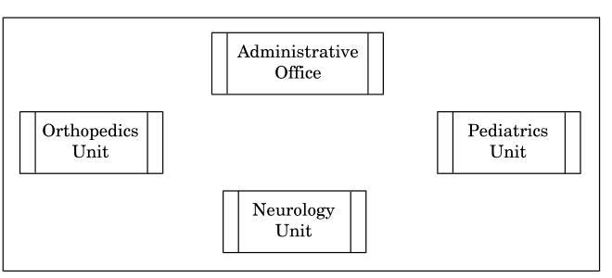  - Suggest a suitable layout for Networking the computer of all wings  - Name the wing where the server is to be installed. Justify your answer.  - Suggest the devices to be installed in each of these buildings for connecting computers installed within the building out of the following:  ● Gateway  ● Modem  ● Switch  iv) Write the name of the type of network out of the following, which will be formed by connecting all the computer systems across the network |  | 4
  Administrative Office to Orthopedics Unit | 55
  Neurology Unit to Administrative Office | 30
  Orthopedics Unit to Neurology Unit | 70
  Pediatrics Unit to Neurology Unit | 50
  Pediatrics Unit to Administrative Office | 40
  Pediatrics Unit to Orthopedics Unit | 110
  Pediatrics Unit | 40
  Administrative Office | 140
  Neurology | 50
  Orthopedics Unit 80 | 80

